R G

***RAVI GREEN ENGINEERING COMPANY***

*Engineers, Fabricators and Erectors*

RAVI GREEN

Dated: <To2>

**TO WHOM IT MAY CONCERN**

It is certified that Mr. <Name> S/o <fname> worked in Ravi Green Engineering Company as <Designation> from <From2> to <To2> at “Moregah Attock Oil Refinery”.

During his stay in our organization we found him hard working and having a good moral character. We have no objection on his doing work at any where.

We wish him best of luck for his success in his future life.

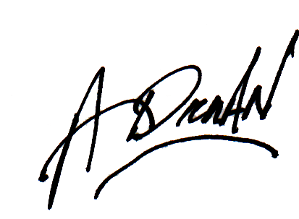

Mubashir Hassain Project Manager.

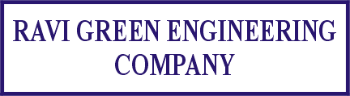

**Office & Work:** 20th Km (Pajian) Raiwind Road, Lahore

Tel: +92(42)5393320 Mobile: 0300-9458077 Fax: +92(42)5393319

Website: http://www.ravigreen.com E-mail: ravigreen@hotmail.com